1. **Three Tier web application using docker and Kubernetes**

**a)dockers**

get files from github link

[javahometech/docker-compose-3-tier (github.com)](https://github.com/javahometech/docker-compose-3-tier)

download zip file extract it

In Visual studio save dockers-compose.yml file

Run cmds in power shell

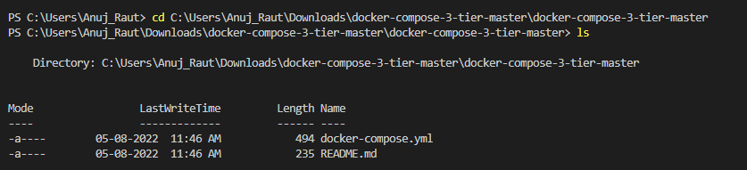

docker-compose up -d

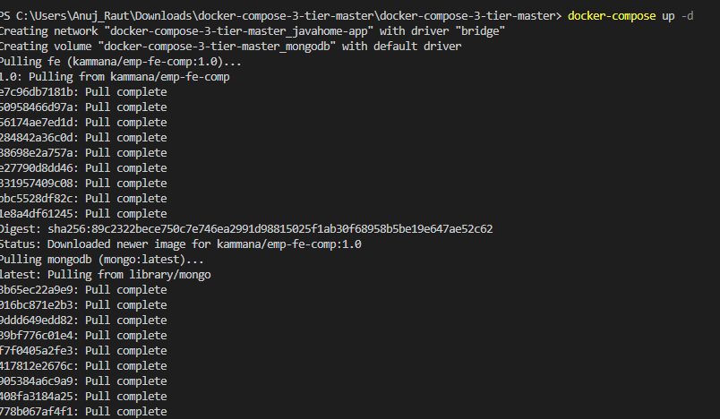

Docker ps

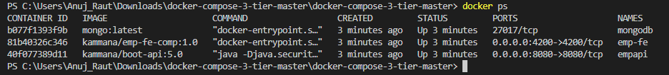

Open the browser

[http://localhost:4200](http://localhost:4200/)

output

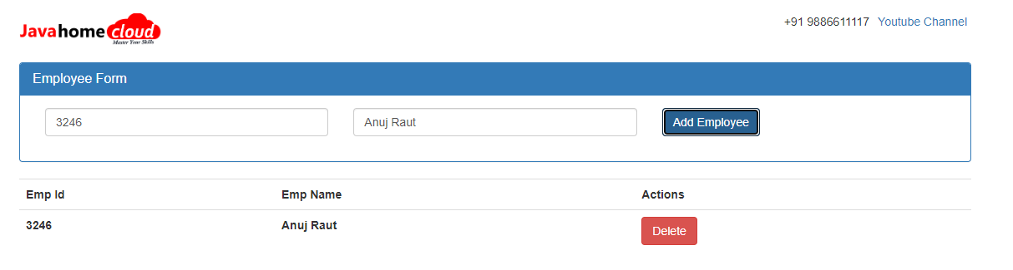

**3.Tier Architecture using Kubernetes**

Step 1

Open katacoda in google

Type kubeless

It will start

Step2

Clone below link

git clone <https://github.com/tahashahidalvi/3-tier-kubernetes.git>

ls

Step 3

cd 3-tier-kubernetes

Step 4

kubectl apply -f 3-tier-deployment.yaml

Step 5

kubectl get nodes -o wide

Step 6

kubectl get service

Go to kubeless UI tab

Copy above port number from get services and paste there

output

Enter some text and click generate URL AND copy PASTE IN NEXT TAB

